

DROPLET PRECAUTIONS
In addition to STANDARD PRECAUTIONS
VISITORS:
Please check with the nursing staff before entering the room. Visitors are limited to 2 at any one time.
PELAWAT:
Sila berhubung dengan Jururawat sebelum masuk ke dalam bilik isolasi. Dihadkan hanya 2 orang pelawat sahaja sekali masuk

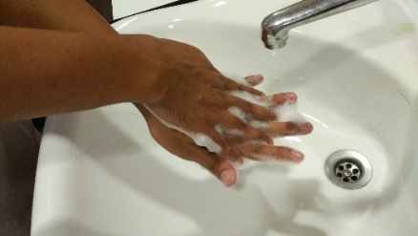
Perform hand hygiene
Lakukan cucian tangan

Pakai surgical mask semasa berada di jarak 1 meter dari pesakit
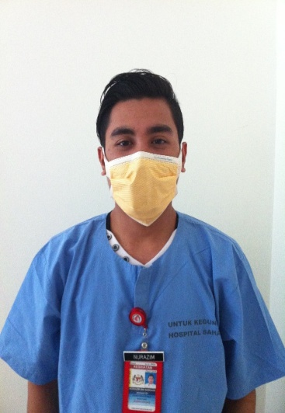
Wear a surgical mask within 1 meter of the patient

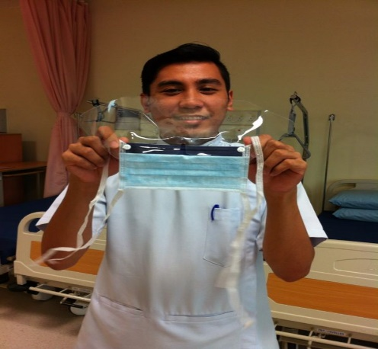
Wear protective eyewear if anticipating splashes to eyes / face
Pakai alat pelindung mata sekiranya ada risiko percikan ke mata / muka

